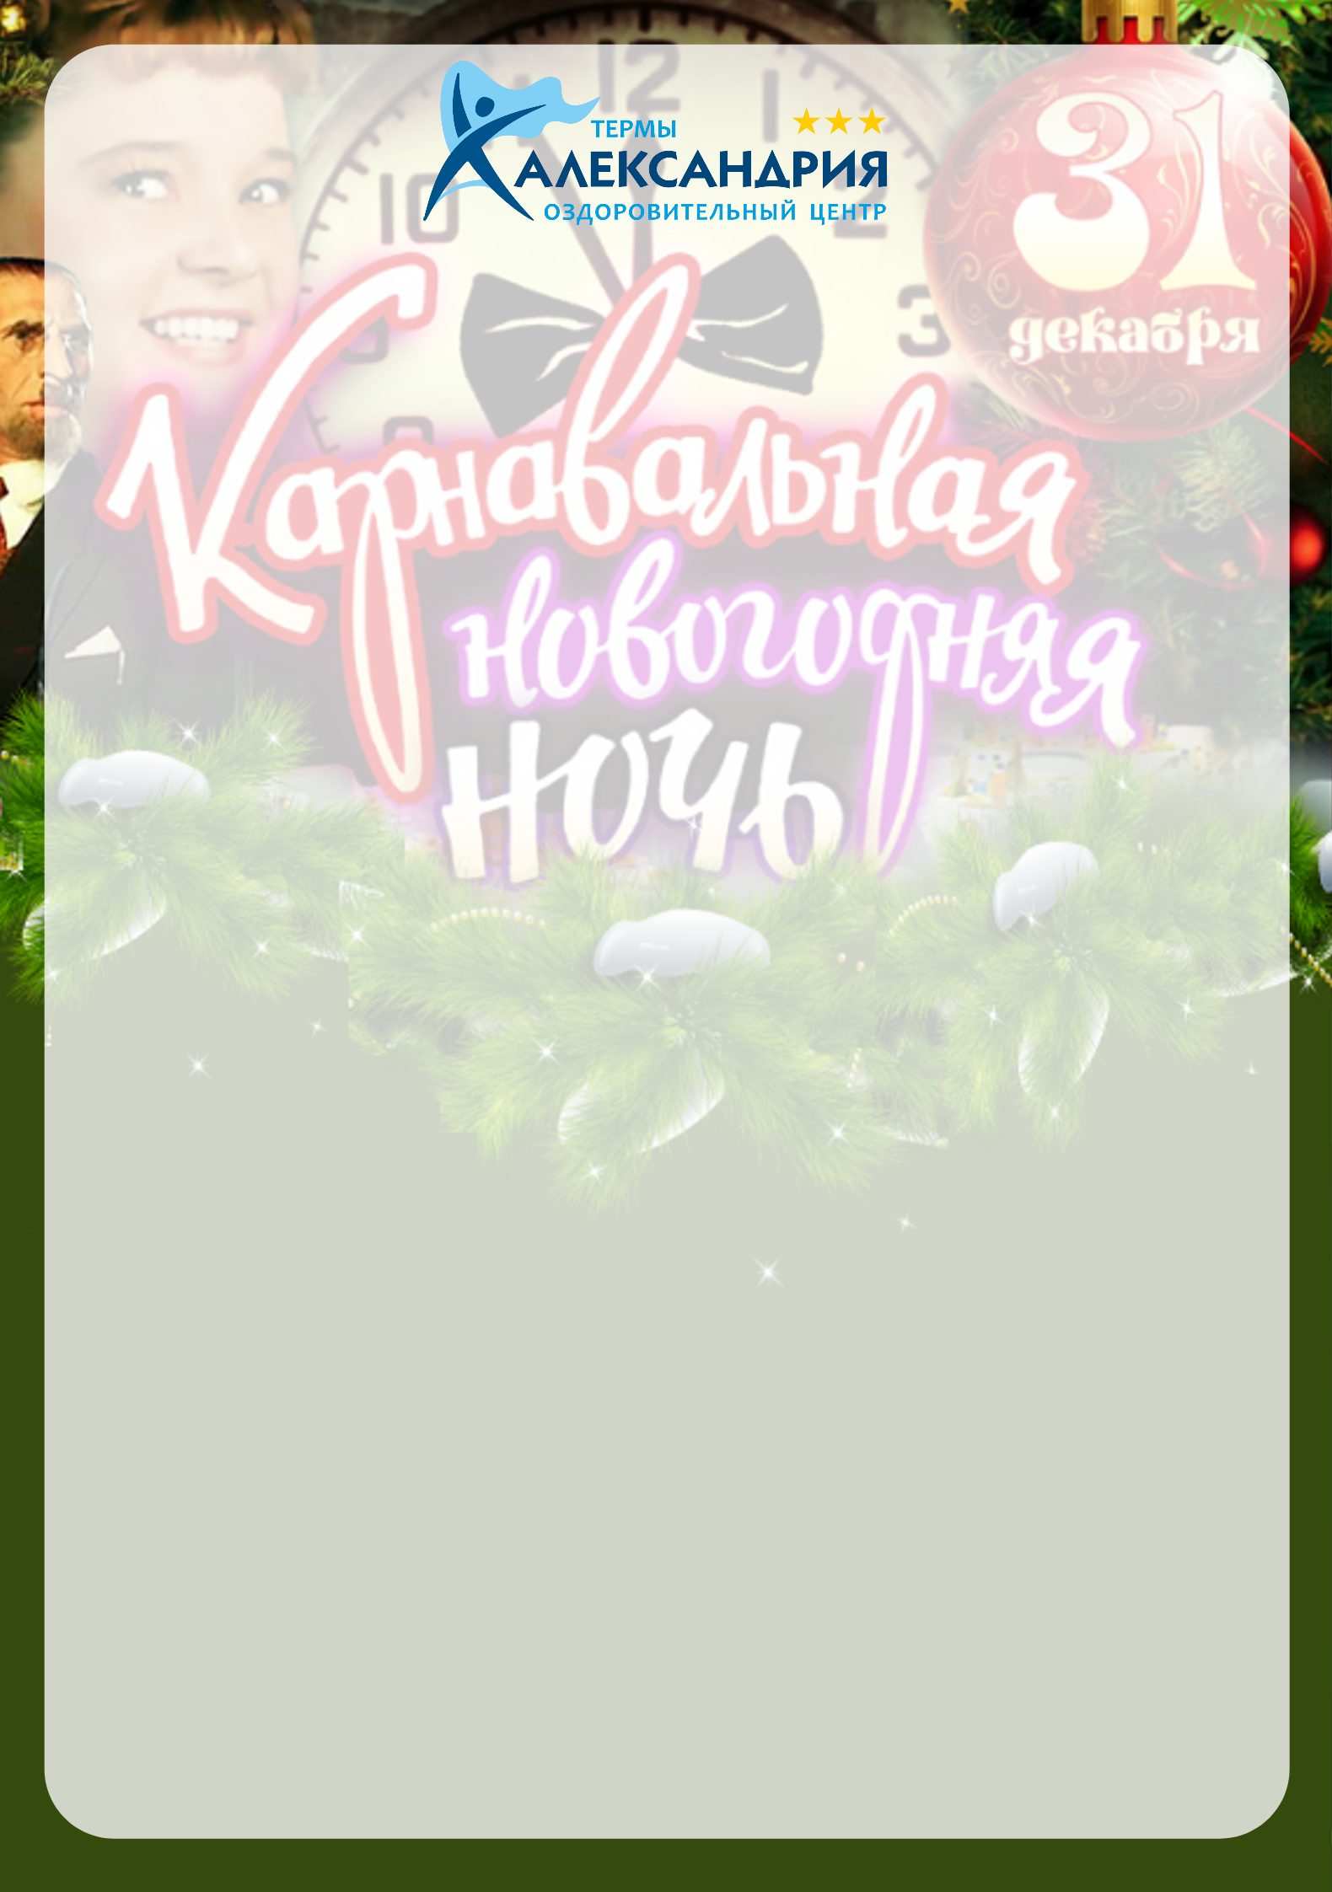

THERMAL SPA ALEXANDRIYA

New Year’s buffet
31 December 2019 in 14:00 pm
Semisweet shampagne (for adult)
Berry drink
Menu of New Year’s Eve
31 December 2019 in 22:00 pm

SALADS

Salad «Salade Olivier» (portion for each guest) 160 g
«Vinaigrette with sprats» (portion for each guest) 200 g
Cold dishes

«Russian meat appetizer» 280 g
(roast pork, salt lard, beef tongue, chicken roll with plums, horseradish, greens)
«My fish» 200 g
(salmon s/s, balyk c/s, mackerel, lemon, olives)
« Pickles » 310 g
(pickled honey agarics, gherkins, pickled tomatoes, sauerkraut, greens)
«Merchant snack» 200 g
(three types of overseas cheeses, honey, walnut, greens)
«Mushroom basket» 180 g
(salt mushrooms, red onion, sour cream)
«Fruit plate» 550 g
(pineapple, tangerines, pear, kiwi, grape)
Hot appetizers

«Chicken julienne» 140 g
(chicken breast fillet, cream, cheese, greens)
«Mushrooms julienne» 140 g
(champignons, onion, cream, cheese, greens)
«Mixed julienne» 140 g
(champignons, chicken breast fillet, cream, cheese, greens)
Hot dishes
«Boiled pork with potato pancakes and sour cream» 290 g
(baked pork neck, potatoes, sour cream, greens)
« Orlovski pike perch» 310 g
(pike perch fillet, champignons, cream, lemon, olives)
Pastry and desserts
«Russian pie» 250 g
(puff pastry, pork, potatoes, onion, greens)

«Sovdepovsky tubes with protein cream» 200 g

Bread basket
Three types of hot crispy buns with green butter 120 g
Drinks for four people
Tarragon/Duchess 1 l
Mineral water «Alexandriya» carbonated/non-carbonated 1l
Cranberry juice 1 l
Black/green tea 4 pcs
«Only in moderation» for four people
Vodka «Russian» 0,5 l
Champagne «Soviet » 0,7 l
Wine «Muscat» 0,7 l
«Who does not mind»
Cigarettes «Prima» 1 pack
Cigarettes «Belomorcanal » 1 pack

