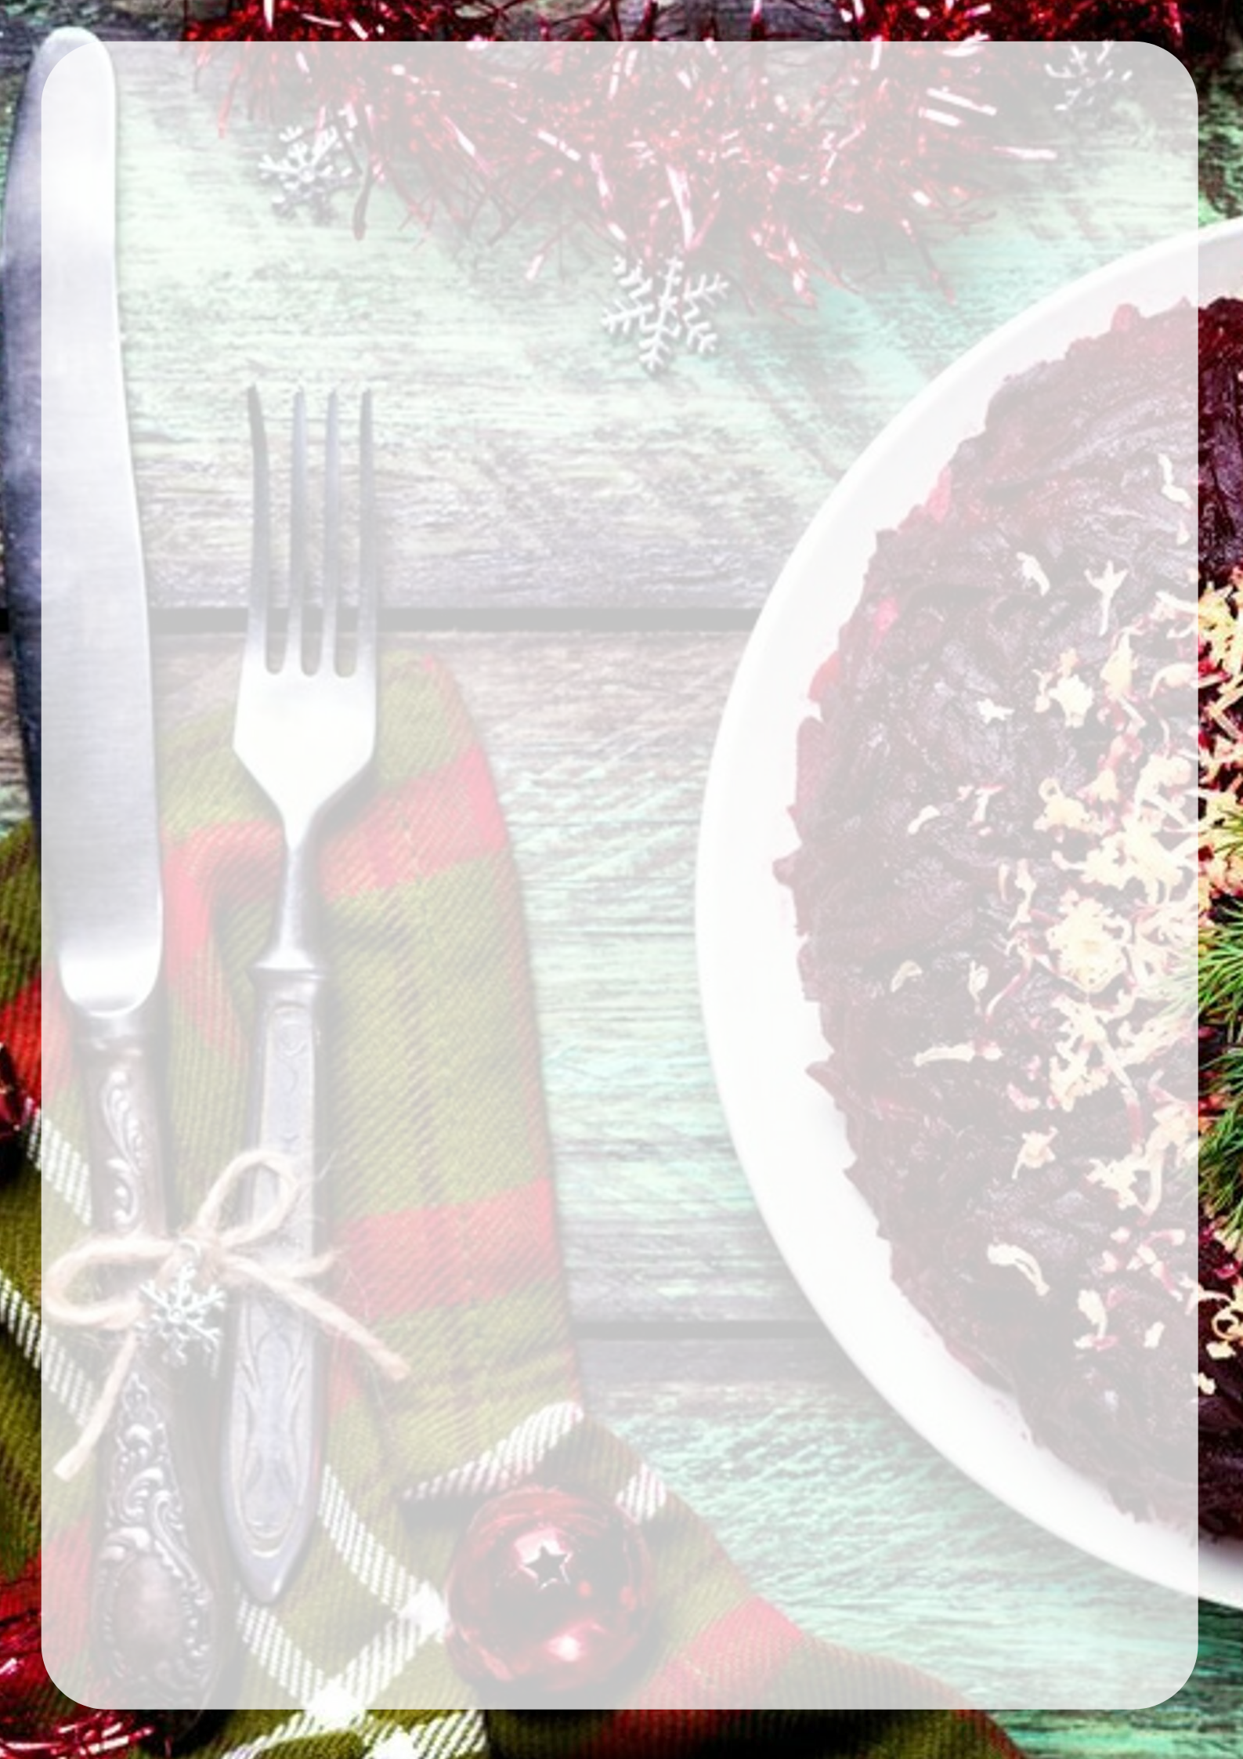

BREAKFAST 01/01/ 2020 |  |  |  | SUPPER 01/01/ 2020 in 19:00 pm
from 10:00 am to 12:00 pm |  |  |  | «New year has come!»
Champagne | 175 ml |  |  | Salads
Mineral water «Alexandriya» | 0,5 l |  |  | Salad «Mimosa» with saury | 200 g
Black/ green tea | 1pc |  |  | Salad " Capital" | 160 g
Hot milk | 200 ml |  |  | Cold snacks
Egg with mayonnaise and green peas | 120 g |  |  | "Traditional snack"  (herring with onion, potatoes and greens) | 220 g
Milk porridge « Hercules» | 210 g |  |  | Smoked ham rolls « Peasant» | 230 g
Siberian ravioli | 200 g |  |  | Salmon rolls « Old Russia» | 190 g
Wheat/ rye bread | 40 g |  |  | «Beef tongue with pickles and horseradish | 230 g
Dry breakfast | 50 g |  |  | «Georgian Khachapuri» | 460 g
Jam | 30 g |  |  | Hot dishes
Sour cream | 50 g |  |  | «Steak with egg and mashed potatoes» | 200\150 g
 |  |  |  | «Chicken schnitzel with potato slices» | 250\150 g
LUNCH 01/01/ 2020 TENT |  |  |  | Bread basket
«Cheburechnaya » from 14:00 pm to 16:00 pm |  |  |  | Bread of own production ( wheat/rye) | 40 g
«Cheburek with meat» 2 pcs. | 150 g |  |  | Dessert | 220 g
«Sausage in dough" 1 pc. | 100 g |  |  | «Pancakes with ice-cream»
«Sandwiches with sprats» 2 pcs. | 160 g |  |  | Drinks
Fish-soup « Fishing» | 250 g |  |  | Buckthorn juice | 0,25 l
Mulled wine | 150 g |  |  | Mineral water «Alexandriya» | 0,5 l
Black/ green tea | 1 pc |  |  | Juice | 0,2 l
 |  |  |  | Champagne | 175 ml
 |  |  |  | Black / green tea | 1 pc
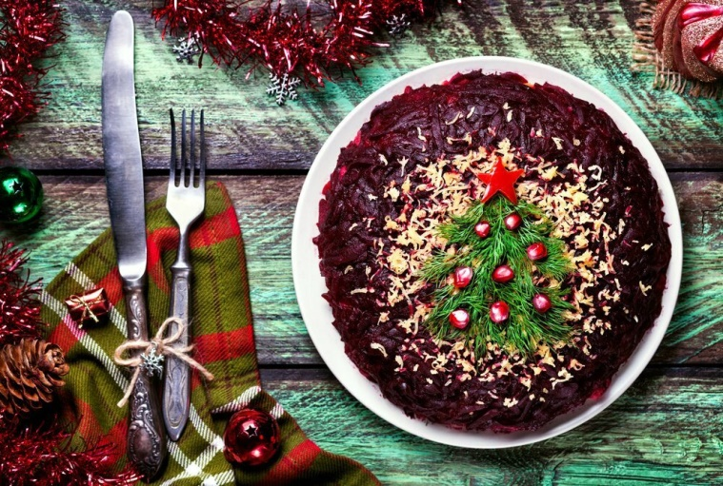
 |  |  |  | Breakfast 02/01/ 2020 from 10:00 am to 12:00 pm
 |  |  |  | Cottage cheese pancakes with condensed milk | 130 g
 |  |  |  | Cooked semolina « Guryevskaya » | 210 g
 |  |  |  | Butter | 10 g
 |  |  |  | Broth with egg and croutons | 250 g
 |  |  |  | Dry breakfast | 50 g
 |  |  |  | Hot milk | 200 ml
 |  |  |  | Sour cream | 50 g
 |  |  |  | Jam | 30 g
 |  |  |  | Wheat/rye bread | 40 g
 |  |  |  | Black/green tea | 1 pc

